Network Scanning & Enumeration of Metasploitable 2 using Nmap

Prepared for:
Cybersecurity Portfolio Project

Prepared by:
Thato Montjane
Contents
Executive Summary 2
Purpose 2
Scope 2
Assessment Objectives 3
Lab Environment 3
Methodology 3
Phase 1 – Environment Setup 3
Phase 2 – Host Discovery 4
Phase 3 – Network Scanning 4
Phase 4 – Service Enumeration 4
Phase 5 – Operating System Detection 4
Phase 6 – Risk Assessment 4
Executive Findings 4
1. FTP Service (Port 21) 4
Finding 4
Risk 4
Recommendation 5
2. SSH (Port 22) 5
Finding 5
Risk 5
Recommendation 5
3. Telnet (Port 23) 5
Finding 5
Risk 5
Recommendation 5
4. SMTP (Port 25) 5
Finding 5
Risk 6
Recommendation 6
5. DNS (Port 53) 6
Finding 6
Risk 6
Recommendation 6
6. HTTP Web Server (Port 80) 6
Finding 6
Risk 6
Recommendation 6
7. SMB (Ports 139 & 445) 7
Finding 7
Risk 7
Recommendation 7
8. Database Servers 7
Finding 7
Risk 7
Recommendation 7
9. VNC (Port 5900) 7
Finding 7
Risk 7
Recommendation 8
10. Operating System Detection 8
Finding 8
Risk: 8
Recommendation 8
Overall Risk Assessment 8
Conclusion 8
Appendix A 9
Appendix B 9

Executive Summary

Purpose
The purpose of this assessment was to perform network reconnaissance and service enumeration against a deliberately vulnerable Linux host (Metasploitable 2) using Nmap. The assessment aimed to identify active services, discover open ports, determine operating system information, and evaluate potential security risks associated with exposed network services.

Scope
The assessment included:
- One target host (Metasploitable 2)
- Target IP Address: 192.168.56.101
- Network reconnaissance using Nmap
- Service enumeration
- Operating system detection
- Basic risk assessment
No exploitation of identified services was performed.

Assessment Objectives
The objectives of this assessment were to:
- Identify active network services
- Discover open TCP ports
- Enumerate service versions
- Identify the target operating system
- Assess the exposed attack surface
- Recommend security improvements
- Demonstrate practical network reconnaissance techniques

Lab Environment
Component | Details
Scanner | Nmap 7.95
Scanner Host | Kali Linux
Target | Metasploitable 2
Virtualization Platform | Oracle VirtualBox
Target IP | 192.168.56.101
Network | Host-Only Adapter

Methodology

Phase 1 – Environment Setup
- Started Kali Linux and Metasploitable 2 virtual machines.
- Verified network connectivity.
- Confirmed communication using ICMP ping.

Phase 2 – Host Discovery
Performed an initial Nmap scan to verify that the target host was online and identify accessible TCP ports.

Phase 3 – Network Scanning
Conducted TCP port scanning to identify open services exposed by the target system.

Phase 4 – Service Enumeration
Used Nmap service detection to identify service names, software versions, and banner information.

Phase 5 – Operating System Detection
Performed operating system fingerprinting to estimate the operating system running on the target host.

Phase 6 – Risk Assessment
Evaluated exposed services based on:
- Security configuration
- Known risks
- Potential attack surface
- Industry security best practices

Executive Findings

High-Risk Findings

1. FTP Service (Port 21)
Service
vsftpd 2.3.4

Finding
Anonymous FTP login is enabled.
Risk: High
Allowing anonymous access enables unauthorized users to connect without credentials, increasing the risk of information disclosure or misuse.

Recommendation
- Disable anonymous FTP access.
- Upgrade the FTP server.
- Restrict access to authenticated users only.

2. SSH (Port 22)
Service
OpenSSH 4.7

Finding
The OpenSSH is outdated.

Risk: Medium
SSH provides secure remote administration, but the identified version is outdated and should be upgraded to receive modern security fixes.

Recommendation
- Update OpenSSH.
- Disable password authentication where possible.
- Use key-based authentication.

3. Telnet (Port 23)

Finding
Telnet service enabled.

Risk: High
Telnet transmits credentials in plain text, making it unsuitable for secure environments.

Recommendation
- Disable Telnet.
- Replace it with SSH.

4. SMTP (Port 25)

Finding
The scan identified a Postfix SMTP server with STARTTLS support and SSL-related information.

Risk: Medium
Mail servers can be abused if not properly configured. The scan also shows an expired certificate, which should be replaced in a real-world deployment.

Recommendation
- Replace expired certificates.
- Review SMTP configuration.
- Disable unnecessary services.

5. DNS (Port 53)

Finding
The target is running ISC BIND 9.4.2.

Risk: Medium
Outdated DNS software may contain publicly known vulnerabilities.

Recommendation
- Upgrade BIND.
- Restrict recursive queries where appropriate.

6. HTTP Web Server (Port 80)

Finding
Apache 2.2.8 was detected hosting the Metasploitable web application.

Risk: Medium
An outdated web server can expose known vulnerabilities and increase the attack surface.

Recommendation
- Upgrade Apache.
- Remove unnecessary modules.
- Perform regular vulnerability assessments.

7. SMB (Ports 139 & 445)

Finding
Samba 3.0.20 was detected. The scan also reports, message_signing: disabled.

Risk: High
Disabled SMB message signing increases the risk of certain network attacks, and the Samba version is outdated.

Recommendation
- Enable SMB signing.
- Upgrade Samba.
- Restrict SMB access using firewall rules.

8. Database Servers

Finding
The assessment identified:
- MySQL (3306)
- PostgreSQL (5432)

Risk: High
Exposed database services should not be accessible unless required. Older database versions may also contain known vulnerabilities.

Recommendation
- Restrict network access.
- Apply security updates.
- Use strong authentication.

9. VNC (Port 5900)

Finding
A VNC service requiring authentication was detected.

Risk: Medium
Remote desktop services increase the attack surface if weak credentials or outdated software are used.

Recommendation
- Restrict remote access.
- Use strong passwords.
- Keep software updated.

10. Operating System Detection

Finding
Nmap identified the target as Linux Kernel 2.6

Risk: Medium
The detected Linux kernel is outdated and no longer receives modern security updates.

Recommendation
- Upgrade to a supported operating system.
- Apply security patches regularly.

Overall Risk Assessment
Finding | Risk
Anonymous FTP | High
Telnet | High
SMB Configuration | High
Exposed Databases | High
Outdated SSH | Medium
Apache Web Server | Medium
DNS Server | Medium
SMTP Service | Medium
VNC Service | Medium
Outdated Operating System | Medium

Conclusion
The assessment successfully demonstrated the use of Nmap to perform host discovery, service enumeration, operating system detection, and attack surface analysis. Multiple insecure and outdated services were identified, highlighting the importance of regular network reconnaissance, secure system configuration, and timely patch management. The exercise provided practical experience in identifying potential security risks and documenting findings in a structured manner suitable for cybersecurity reporting.

Appendix A
Tools Used
- Kali Linux
- Nmap 7.95
- Oracle VirtualBox
- Metasploitable 2
Target Information
- Host: Metasploitable2
- IP Address: 192.168.56.101
- Scan Type: Aggressive Scan (-A)

Appendix B
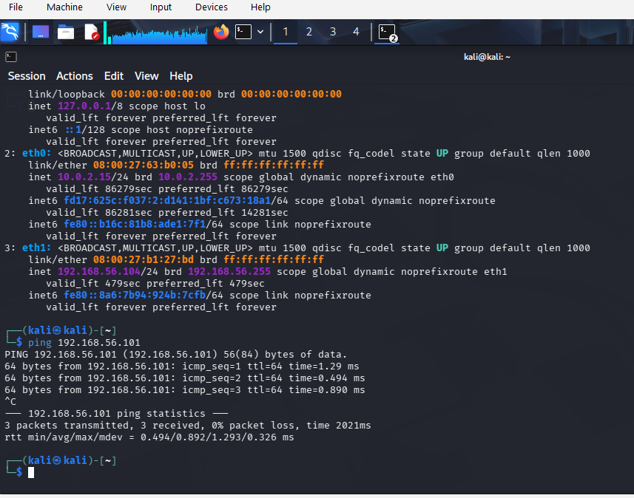
Figure 1- Network connectivity test
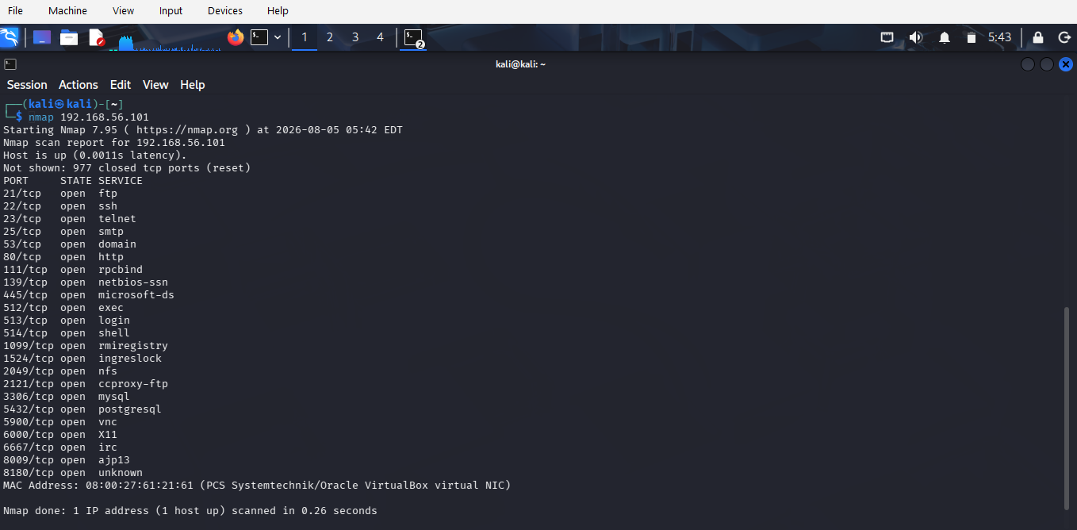
Figure 2- Basic Nmap Scan
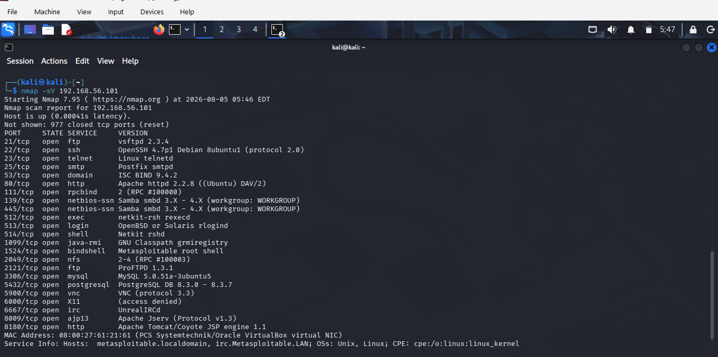
Figure 3- Service Version Detection
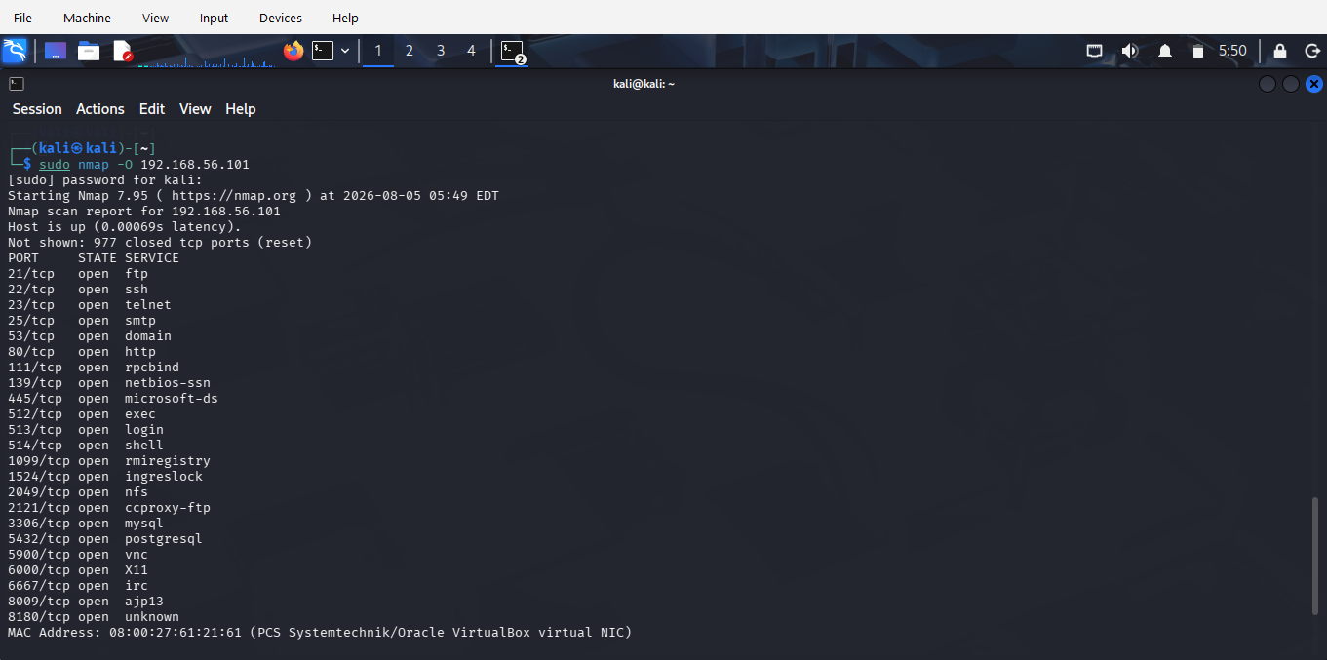
Figure 4- Operating System Detection
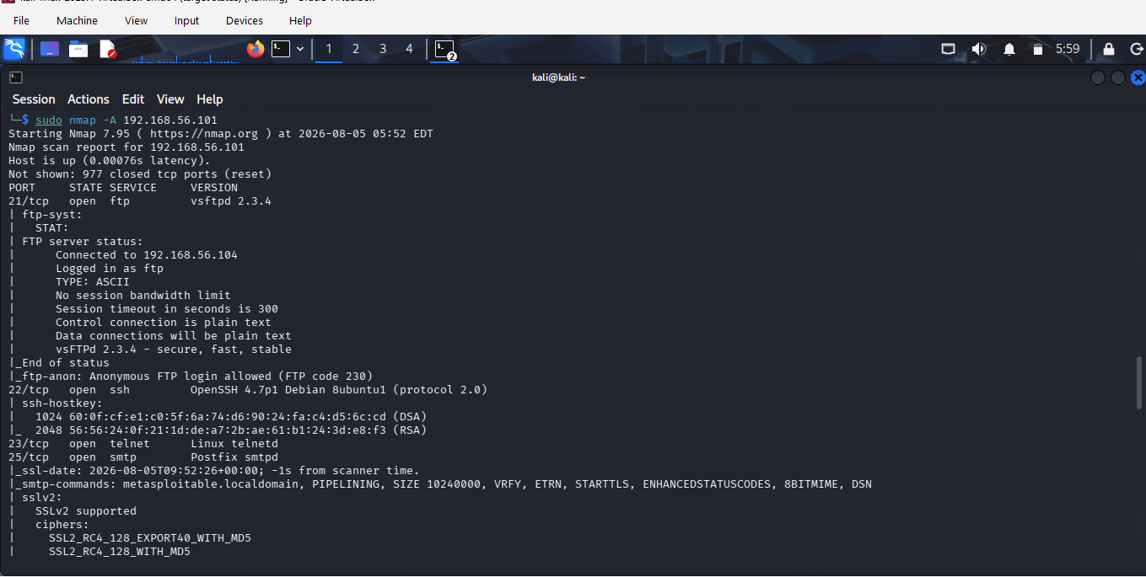
Figure 5- Aggressive Scan Results
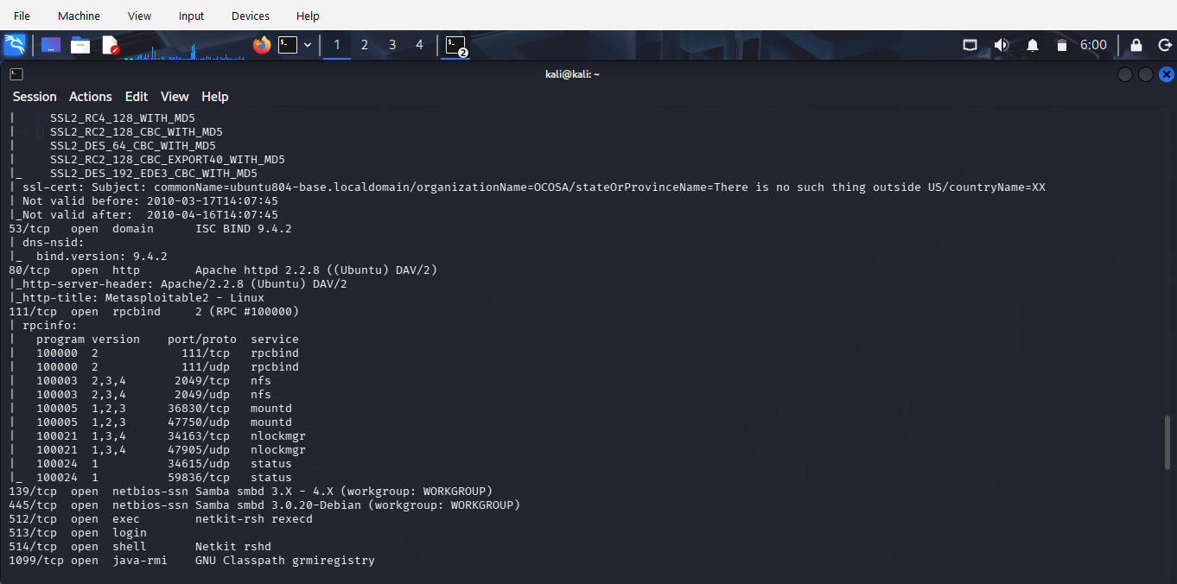
Figure 6- Aggressive Scan Results

